**EXPERIMENT 1**

**(A)**

**Aim:** To study the V-I characteristics of a PN junction diode.

**Apparatus Required:** ITEMS QUANTITY

PN junction Diode (IN4001) 1

DC variable power supply 1

Multi-meter 2

Breadboard 1

Jumper wires as per requirement

**Theory:**

**P-N junction diode**

A PN Junction Diode is one of the simplest semiconductor devices around, and which has the characteristic of passing current in only one direction only. However, unlike a resistor, a diode does not behave linearly with respect to the applied voltage as the diode has an exponential voltage-current (V-I) relationship and therefore we cannot describe its operation by simply using an equation such as Ohm’s law.

Forward bias

Under forward biased condition of a real PN junction diode, the P-side is connected to the positive and N side is connected to the negative terminal of the power supply. This reduces the potential barrier. As a result current flows from P to N-type in forward direction. When the applied voltage is more than the barrier potential, the resistance is small (ideally 0) and the current increases rapidly. This point is called the Knee-point or turn-on voltage or threshold voltage. This voltage is about 0.3 volts for Ge diodes and 0.7 volts for Si diodes.

Reverse bias

Under reverse biased condition, the P-side of the junction diode is connected to the negative and N-side is connected to the positive terminal of the power supply. This increases the potential barrier due to which no current should flow ideally. But in practice, the minority carriers can travel down the potential barrier to give very small current. This is called as the reverse saturation current. This current is about 2-20 uA for Ge diodes and 2-20 nA for Si diodes (the values might differ for diodes of different makes). When the applied reverse voltage is increased beyond the certain limit, it results in breakdown. During breakdown, the diode current increases tremendously.

**CIRCUIT DIAGRAM:**

FORWARD BIAS

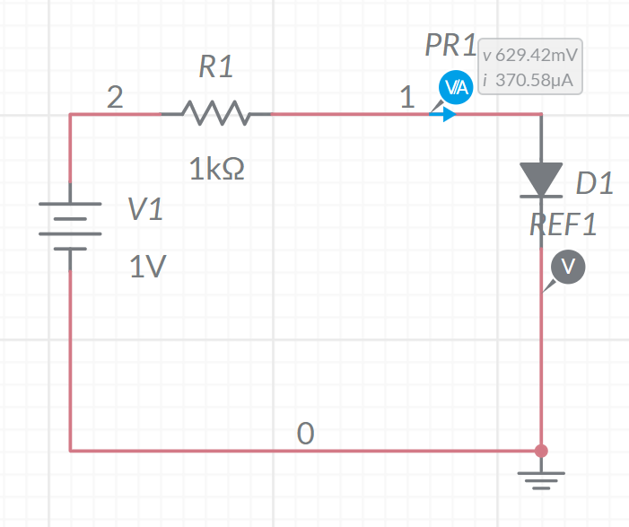

REVERSE BIAS

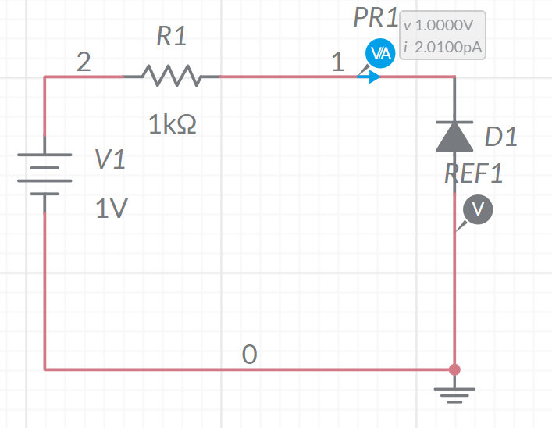

**PROCEDURE:**

1. Connect the experiment in forward bias mode (set the Voltmeter & Ammeter in their proper range).

2. Get the connections checked from the teacher in-charge before giving supply.

3. Switch ON the power supply & adjust the minimum voltage & current on the meter.

4. Slowly increase the supply voltage (starting from 0.1V to 0.7V in a step of 0.1v) and tabulate the readings.

5. Now, switch-off the supply, bring its knob to zero. Now connect the setup in reverse bias mode (set voltage range on multi-meter at 10V & Ampere at 50uA).

6. Switch On the power supply & adjust the minimum voltage & current on the meter.

7. Slowly increase the supply voltage (starting from 1V to 10V in a step of 1V) and tabulate the readings.

8. Plot the V-I characteristics taking V on x-axis and I on y-axis.

**OBSERVATIONS**

The following table represents the observations:

|  |  |  |  |  |  |
| --- | --- | --- | --- | --- | --- |
| **FORWARD BIASING** | | | **BACKWARD BIASING** | | |
| **S.No.** | **Voltage(volts)** | **Current** | **S.No.** | **Voltage(volts)** | **Current** |
| 1 | **100.00mv** | **667.68fA** | **1** | **1V** | **2.010pA** |
| **2** | **200.00mv** | **23.208pA** | **2** | **2V** | **4.010pA** |
| **3** | **300.00mv** | **1.090nA** | **3** | **3V** | **6.010pA** |
| **4** | **399.95mv** | **51.960nA** | **4** | **4V** | **8.010pA** |
| **5** | **497.72mv** | **2.277μA** | **5** | **5V** | **10.010pA** |
| **6** | **566.93mv** | **33.073μA** | **6** | **6V** | **12.010pA** |
| **7** | **596.45mv** | **103.55μA** | **7** | **7V** | **14.010pA** |
| **8** | **611.99mv** | **188.11μA** | **8** | **8V** | **16.010pA** |
| **9** | **621.99mv** | **278.01μA** | **9** | **9V** | **18.010pA** |
| **10** | **629.42mv** | **370.58μA** | **10** | **10V** | **20.010pA** |

**RESULT**

The V-I curve shows that only a very small current flows through the diode during initial stage till the potential barrier is wiped-off. Once the potential barrier is wiped off (i.e.at the knee voltage), the current rises quickly.

**PRECAUTIONS**

1. While doing the experiment do not exceed the ratings of the diode. This may lead to damage of the diode.

2. Always connect the voltmeter in parallel and Ammeter in series.

3. Switch “ON’’ the power supply after completing the circuit.